#### BENTLEY B-007 RG

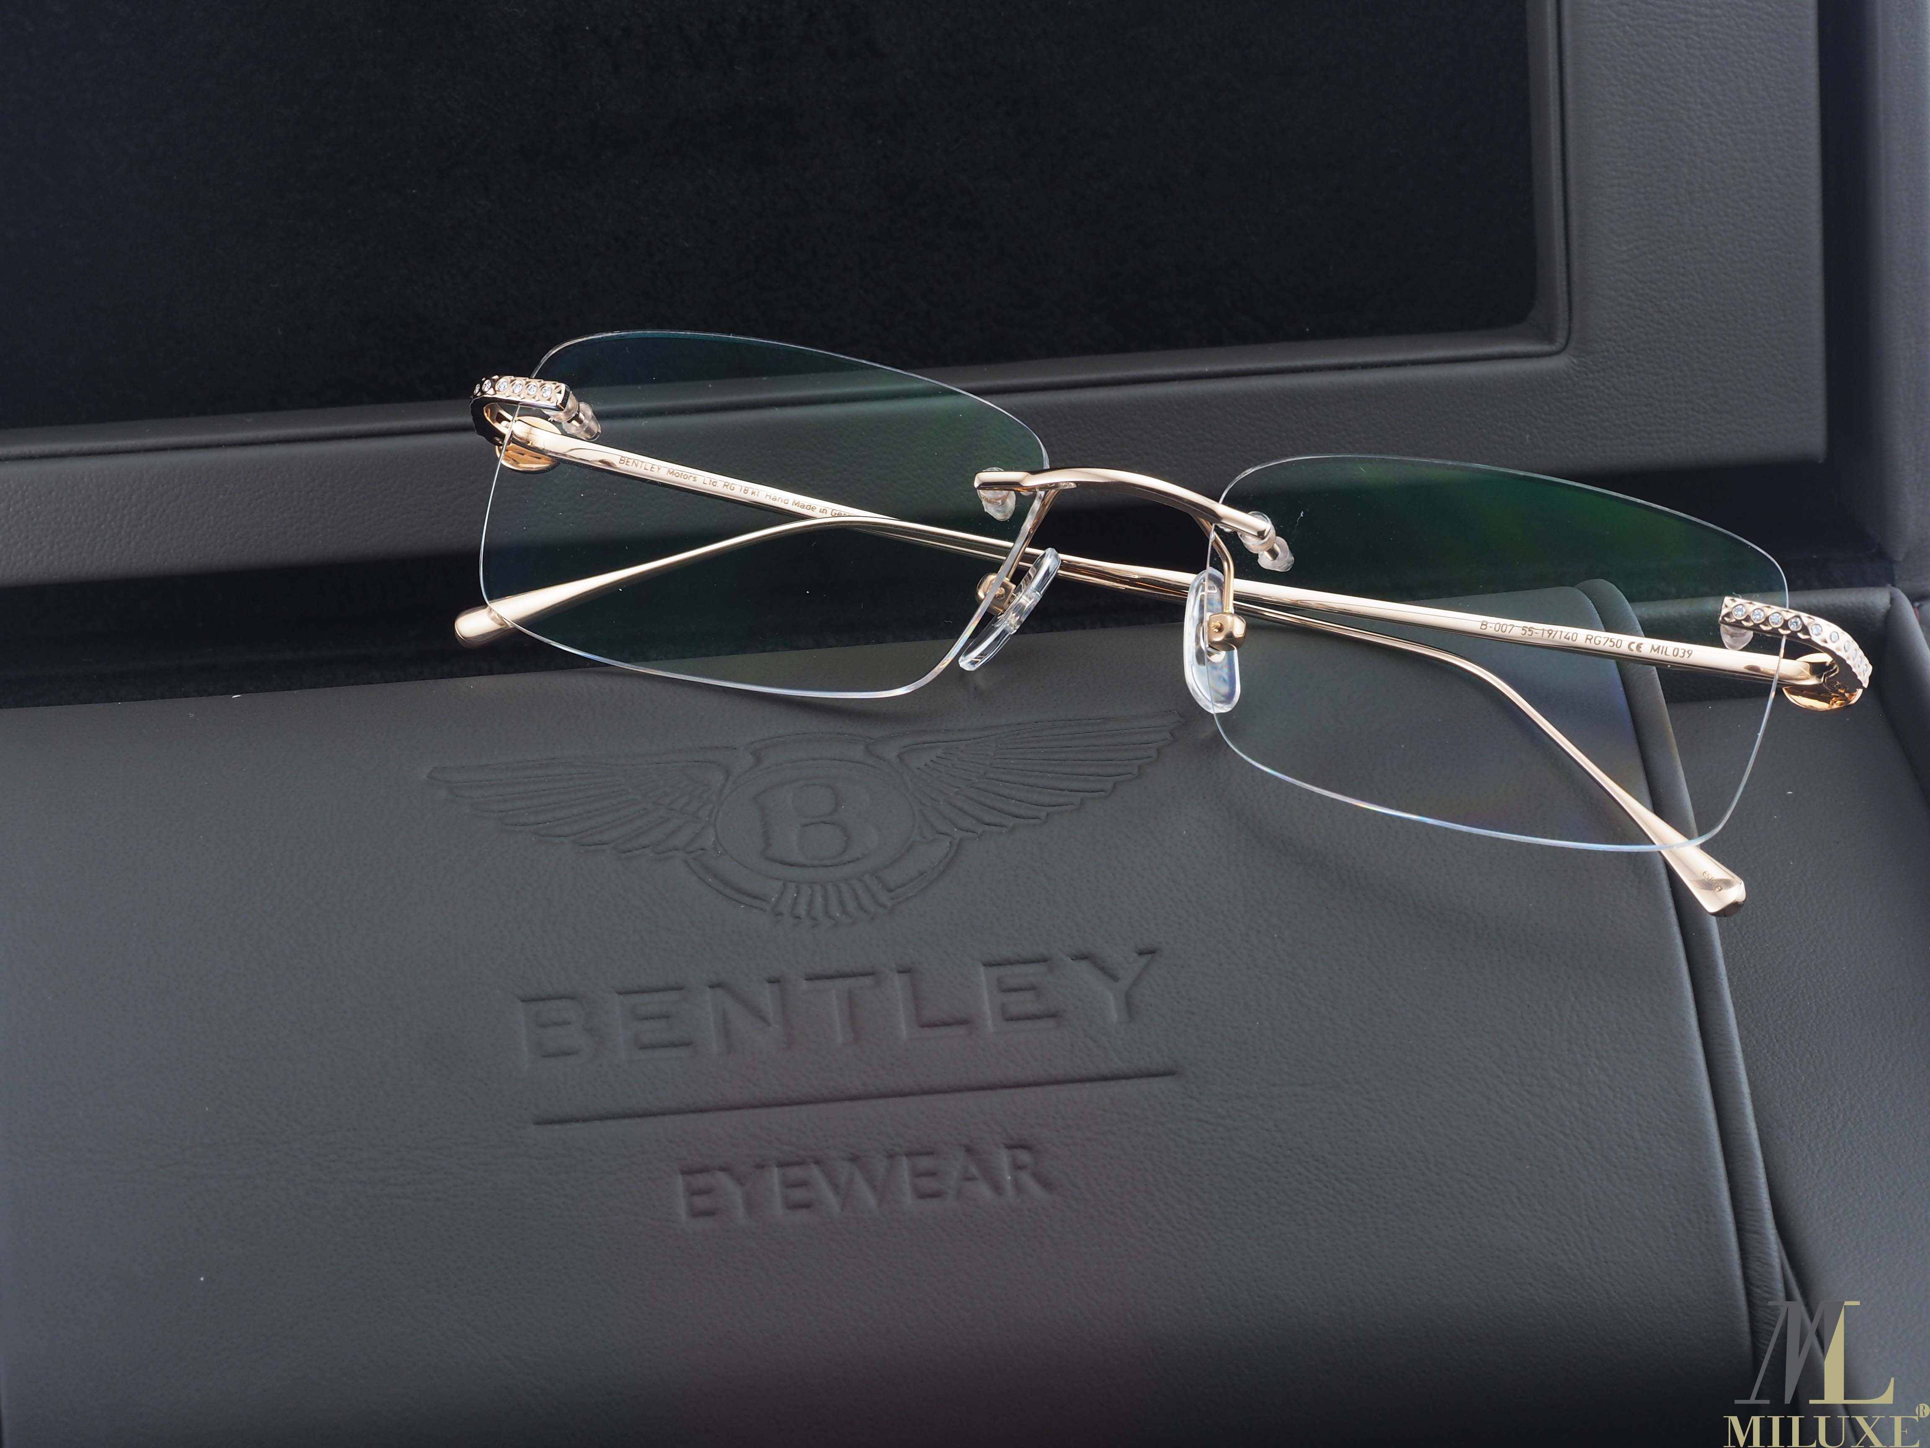

PRICES : 25.000.000 VND

Specifications

* **Shape:** Modified Round
* **Material:**  Rose Gold
* **Hinge:** Regular Hinge
* **Rim:** Semi-Rimless
* **Temple:** Skull
* **Bridge:** Adjustable nose pads
* **Gender:** Male
* **Age Group:** Adult
* **Case:** Hard case included.
* **Manufacturer’s Warranty:** 2-year warranty.
* **Country:** Italy
* **Category:** In Stock
* **Product Group:** Prescription Eyeglasses
* **Edge type:** Beveled
* **Trim:** Plastic trim.
* **Year:** 2017